**Heroku:-** https://dashboard.heroku.com/apps

**App Link:-** https://appreviewscrapper.herokuapp.com/

**Review Scrapper on Local machine:**

1. **Run Application:**

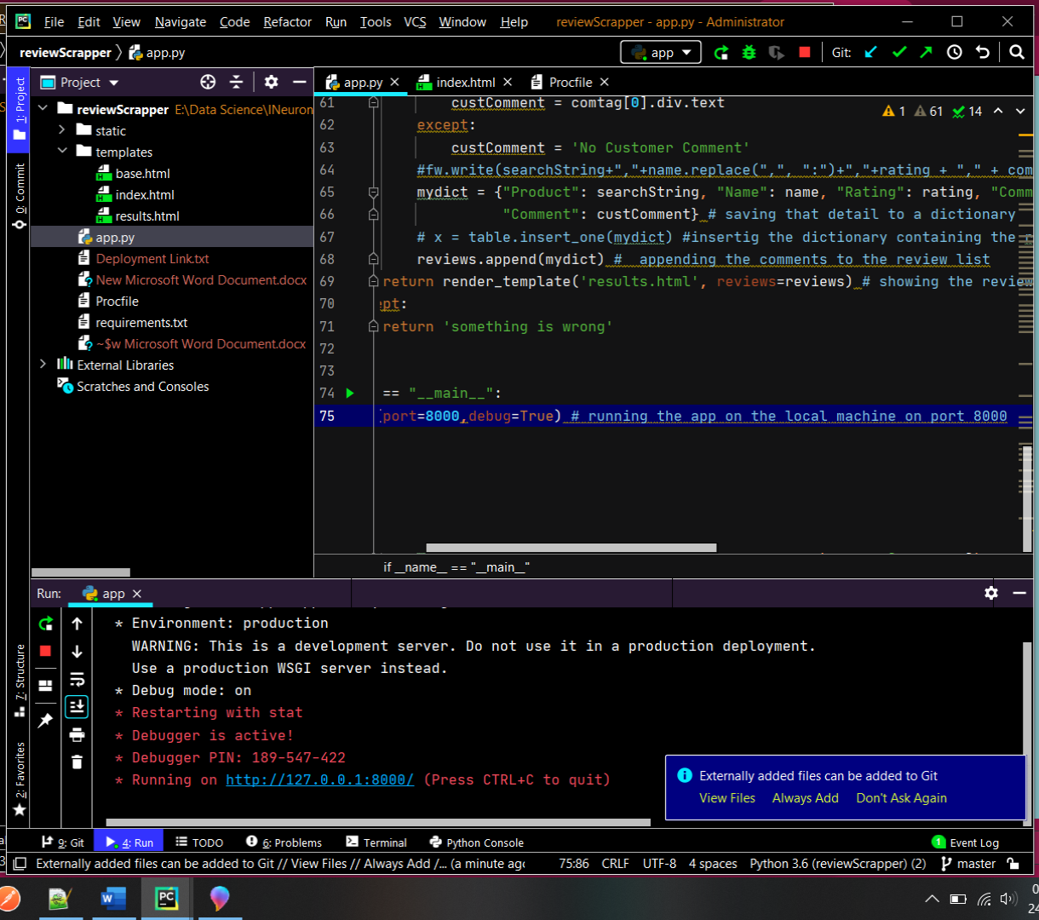

**Run Successfully!**

1. **Search Page**

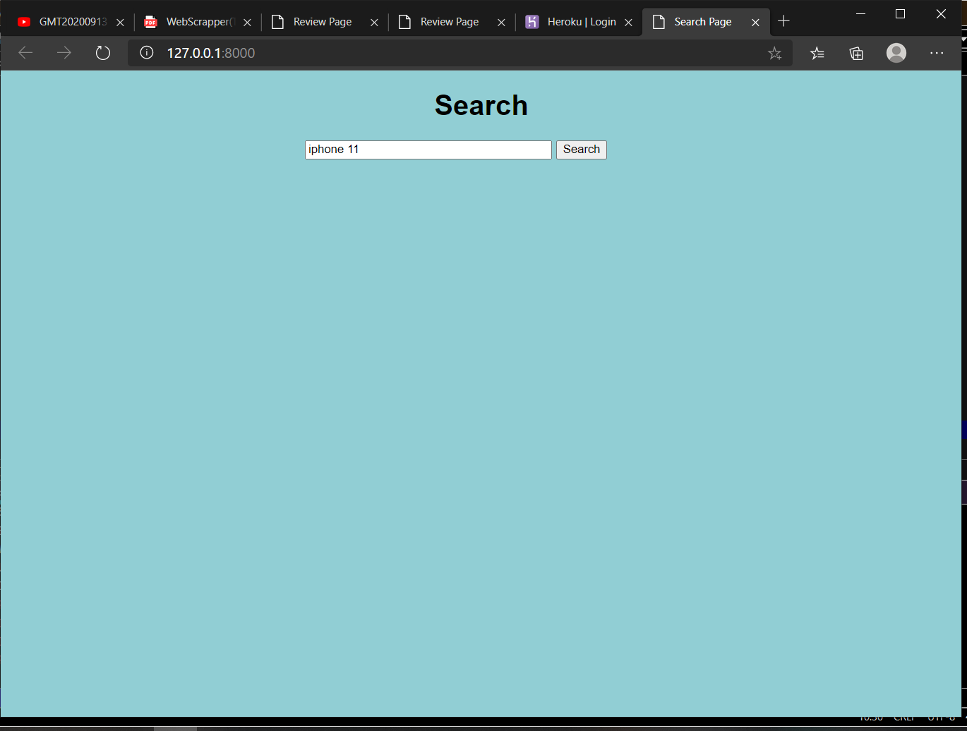

1. **Result**

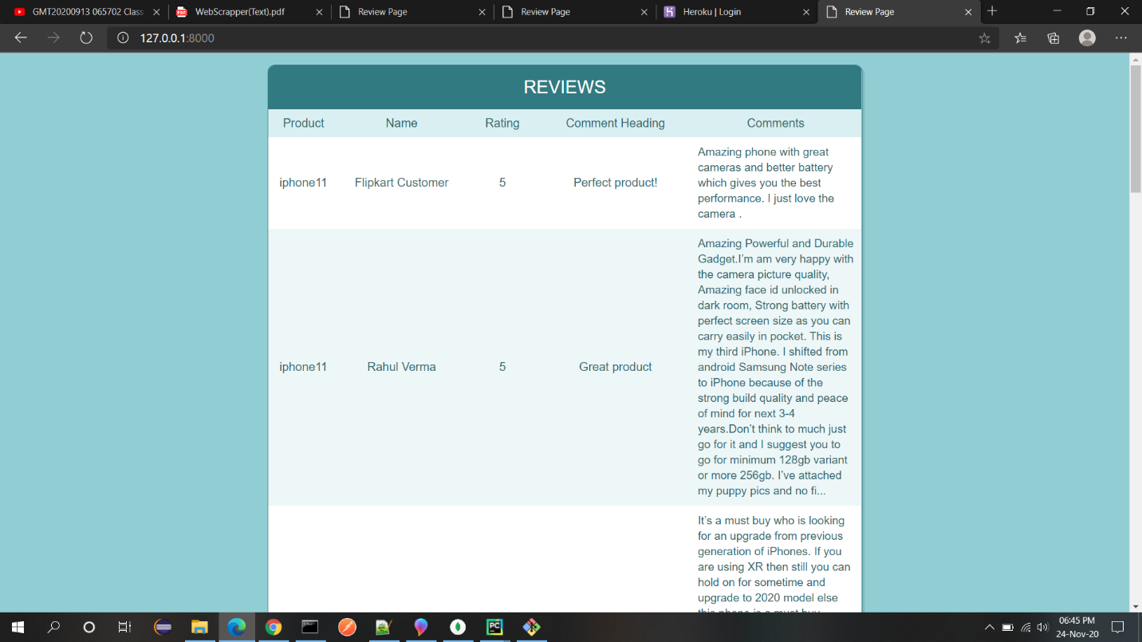

**Got review successfully!**

**Deployment application on Heroku using Git**

**Heroku**: The Python app that we have developed is residing on our local machine. But to make it available to end-users, we need to deploy it to either an on-premise server or to a cloud service. Heroku is one such cloud service provider. It is free to use(till 5 applications). 20 | P a g e We’ll deploy this application to the Heroku cloud, and then anybody with the URL can then consume our app.

1. **Create App**

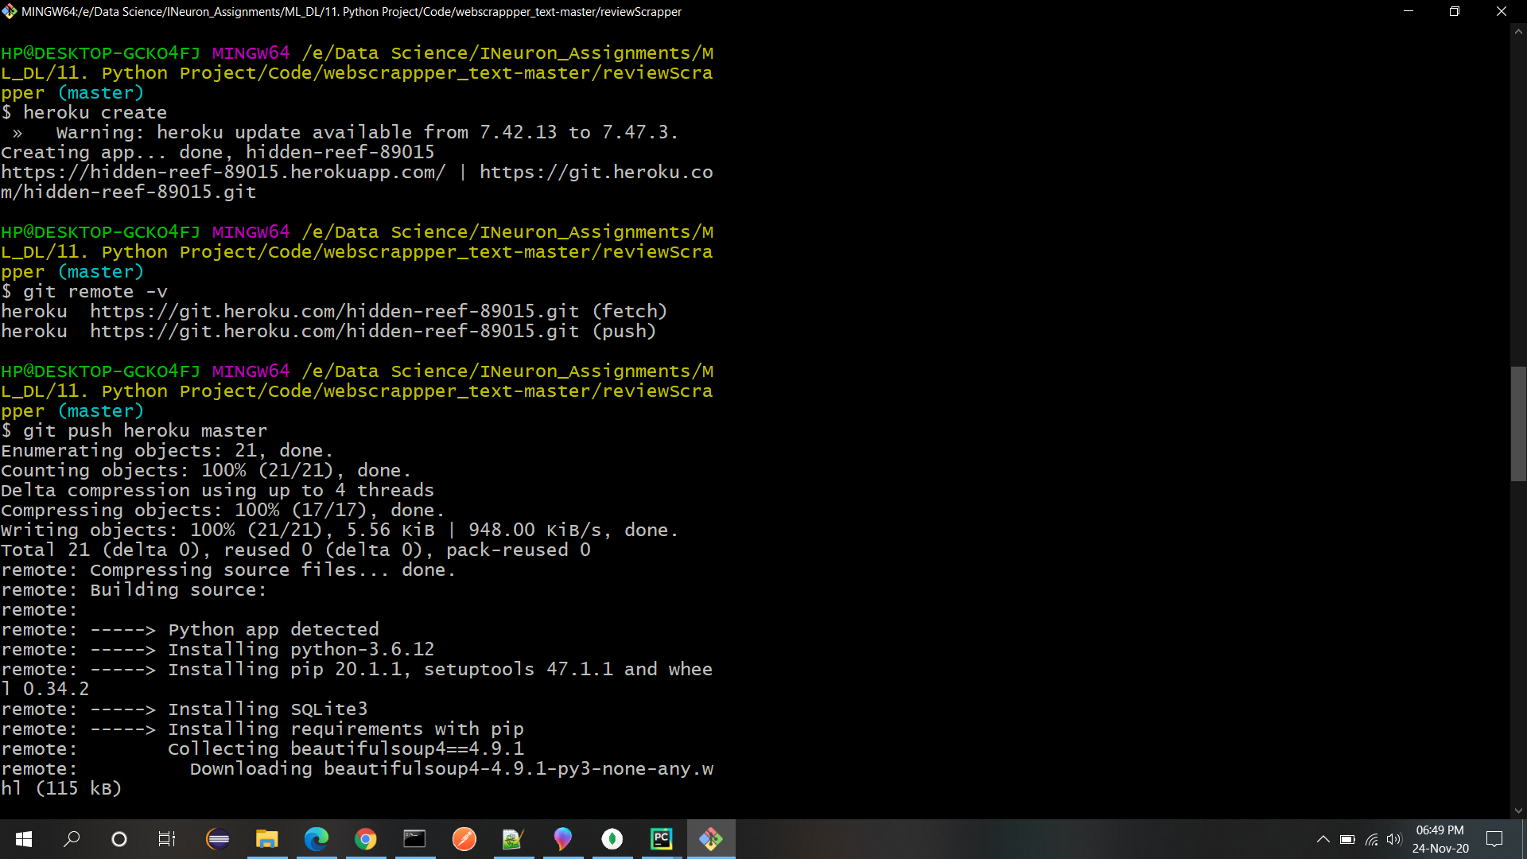

1. **Renaming app**

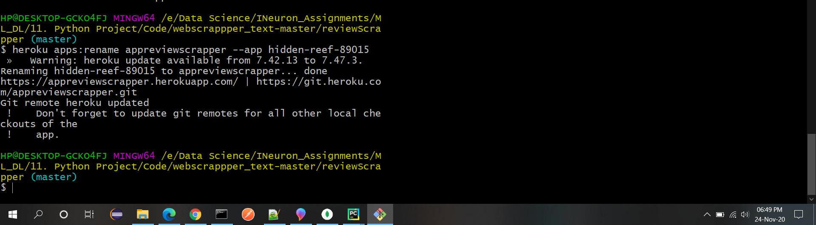

1. **Check deployment**

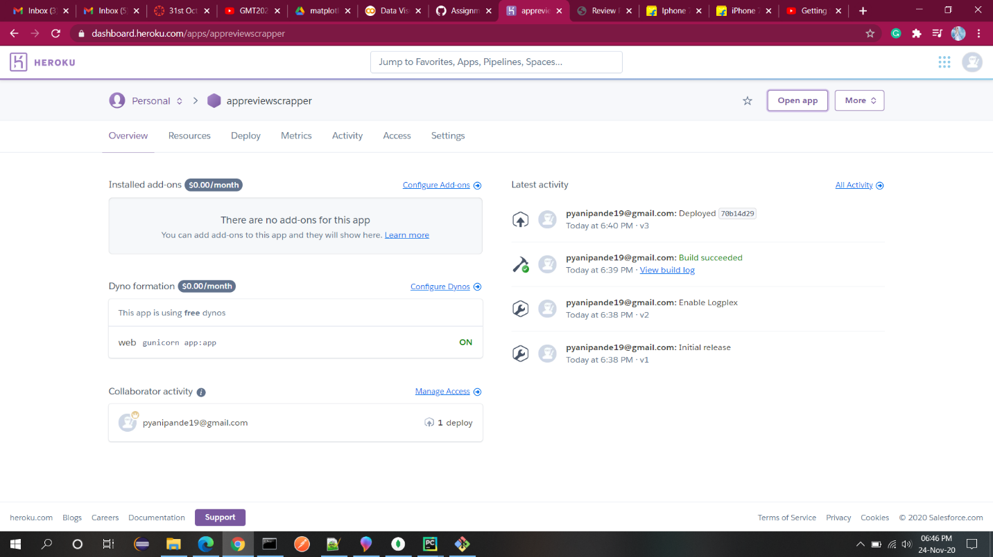

1. **Open App**

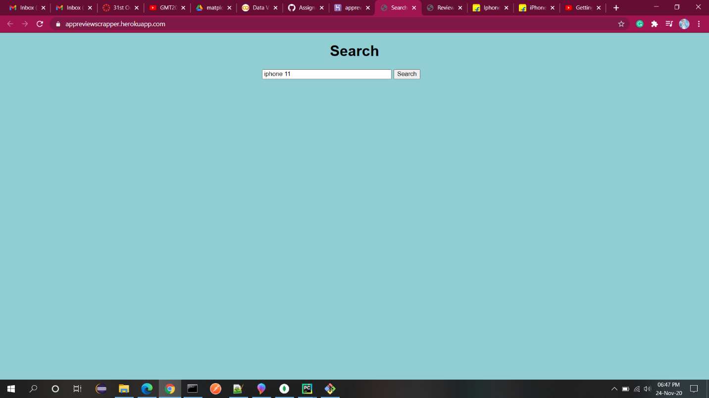

1. **Result**

